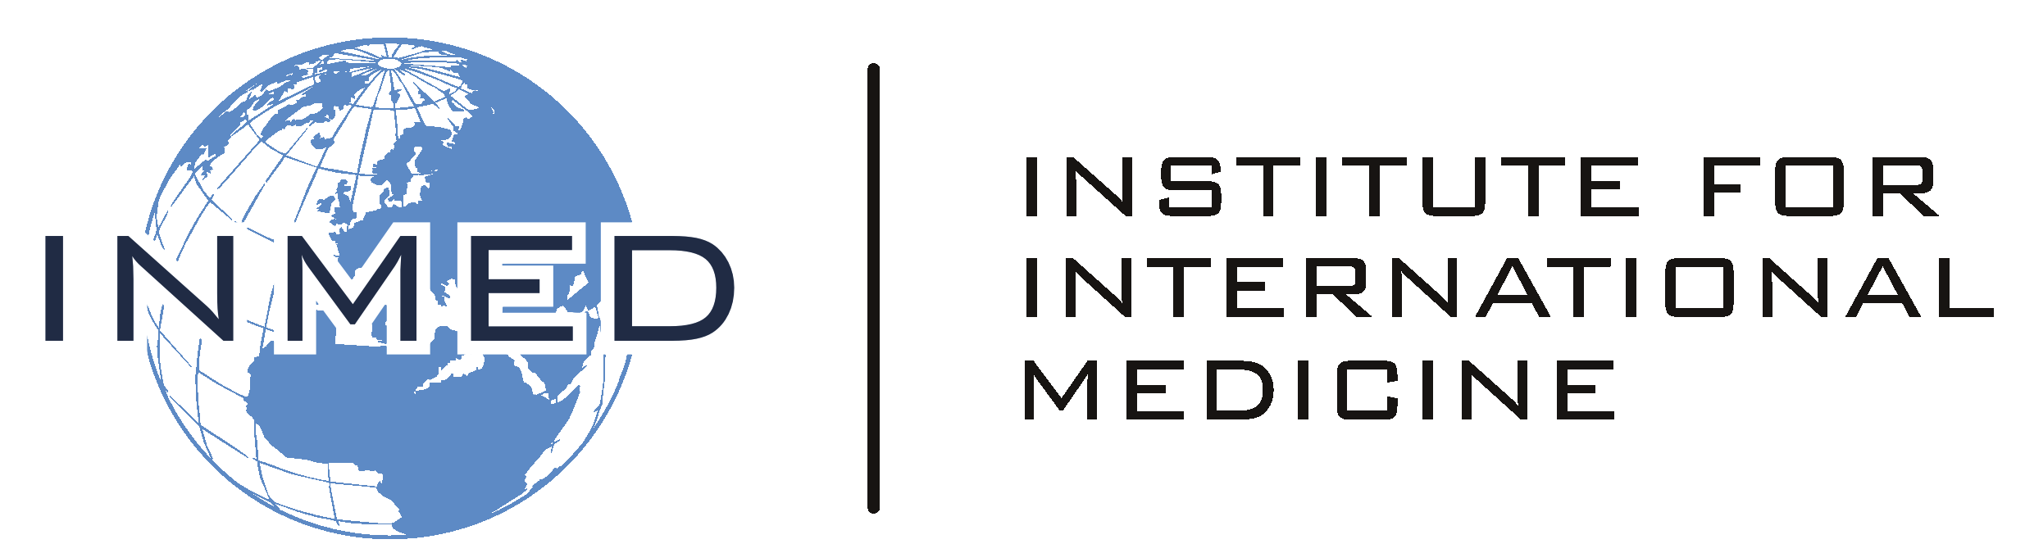

**Presentation Guidelines for**

**International Medicine, International Nursing, and International Public Health Learners**

Education and skill transfer are an essential part of improving health, regardless of the nation or setting. This component of the INMED Service-Learning experience will give you an opportunity to hone your teaching skills, as well as to contribute to the expertise of those at your INMED Training Site.

Soon after arrival, speak with your supervisor about an opportunity to make a presentation for the staff, patients, or community. With the assistance of your supervisor, select a topic on health promotion or disease management relevant to the particular needs or interests of your audience.

A presentation of 20-30 minutes is usually ideal. Allow ample opportunity for questions and comments from your audience. Some useful presentation topics may include:

* Treatment of common infectious disease, such as pneumonia, diarrhea, TB, malaria, and HIV
* Evaluation of febrile illnesses
* Management of postpartum hemorrhage
* Treatment of common chronic non-infectious disease, such as diabetes, hypertension, COPD, and seizure disorder
* Leading causes of death and disability in your region
* Prevention of malnutrition among children
* Prevention common infectious disease, like pneumonia, diarrhea, TB, malaria, and HIV
* Home methods of water purification
* Management of common ethical issues
* Principles of effective healthcare education

Visual aids, like PowerPoint, white board, flip charts, even puppets, may be engaging and useful. Be prepared to adapt to the particular technology available, or unavailable, at your Training Site.

On return from your International Service-Learning experience, please submit to INMED a copy of your presentation, either in full or as an outline. Suitable formats include PPT, PDF and Word.