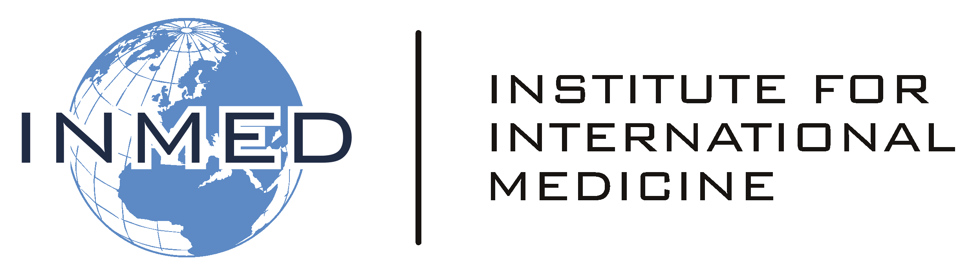

Institute for International Medicine -
International Nursing Elective

To INMED International Faculty

Thank you for your willingness to serve as a mentor for our students. We trust that this experience will cultivate their knowledge and skills in international nursing, as well as foster a vision for their personal career decisions. The following are general objectives for this International Nursing Elective. While each setting is different, we trust that during the weeks INMED students are with you they will advance in these particular areas of knowledge, skills and attitudes.

OBJECTIVES:

Upon completion of the INMED program in International Nursing and Public Health, the INMED student will be able to:

- Management and prevention of the leading diseases of poverty
- Management and prevention of HIV infection
- Care for the health of pregnant women and newborns
- Proficiency in clinical skills useful in low-resource settings
- Skill in community-wide health promotion and death/disability prevention
- Culturally appropriate healthcare
- Proficiency in disaster mitigation and response
- Design and implementation of team-lead healthcare interventions
- Transfer of healthcare skills to other personnel

